Back Tracking:
Yess Talha — exactly! It iterates at each recursive call starting from start index.
Let’s make you sticky notes — like little cheat memory flashcards 📌✨:

📌 Backtracking Sticky Notes
📝 1. What is Backtracking?
- Try one option
- Go deeper (recursively)
- If done — backtrack (remove last)
- Try next option

📝 2. Why for Loop in Backtracking?
- At each recursive level, loop picks possible next numbers
- Each i starts from start index to avoid duplicates

📝 3. When to Remove?
- After recursive call (when returning back)
- Remove the last added item to explore other options
🔄 "Add → Recurse → Remove → Next"

📝 4. Why Sort the Array?
- To handle problems with unique subsets
- Keep results in lexicographical order
- (Here no duplicates, but good habit)

📝 5. Key Flow
[ ]
├── [1]
│ ├── [1, 2]
│ │ └── [1, 2, 3]
│ └── [1, 3]
└── [2]
└── [2, 3]
At each step:
- for-loop runs from current start
- Recursive call is made
- Backtrack by removing last
Sub-Set 1 Problem:
public List<List<Integer>> subsets(int[] nums) {
List<List<Integer>> list = new ArrayList<>();
Arrays.sort(nums);
backtrack(list, new ArrayList<>(), nums, 0);
return list;
}

private void backtrack(List<List<Integer>> list , List<Integer> tempList, int [] nums, int start){
list.add(new ArrayList<>(tempList));
for(int i = start; i < nums.length; i++){
tempList.add(nums[i]);
backtrack(list, tempList, nums, i + 1);
tempList.remove(tempList.size() - 1);
}
}

Sub Set 2 Problem:
Sorting + checking nums[i-1] with nums[i] for duplicates
class Solution {
public List<List<Integer>> subsetsWithDup(int[] nums) {

List<List<Integer>> data = new ArrayList<>();
Arrays.sort(nums);

backTrack(data,new ArrayList<>(),nums, 0);

return data;

}

private void backTrack(List<List<Integer>> data, List<Integer> temp, int[] nums, int start){
data.add(new ArrayList<>( temp ));

for(int i=start; i<nums.length; i+=1){
if( i>start && nums[i-1] == nums[i]) continue;
temp.add(nums[i]);

backTrack(data, temp, nums, i + 1);

temp.remove( temp.size() - 1 );
}
}
}

Permutations:
class Solution {
public List<List<Integer>> permute(int[] nums) {

List<List<Integer>> data = new ArrayList<> ();
backTrack(data, new ArrayList<>(),nums);

return data;
}

private void backTrack(List<List<Integer>> data, List<Integer> temp, int[] nums){
if(temp.size() == nums.length){
data.add(new ArrayList<>( temp ));
}
else {

for(int i= 0; i<nums.length; i+=1){
if( temp.contains(nums[i])) continue;

temp.add(nums[i]);

backTrack(data, temp, nums);

temp.remove( temp.size() - 1 );
}
}

}
}

Back-Tracking Notes:
All subsets and permutations

We need to start from i=0 because if we start from incremented I then previous values will be skipped.
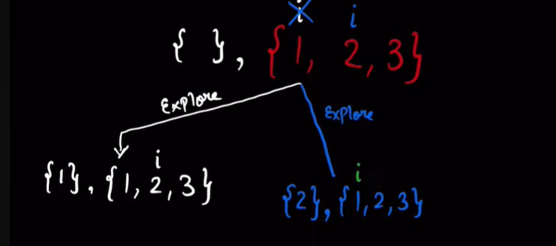
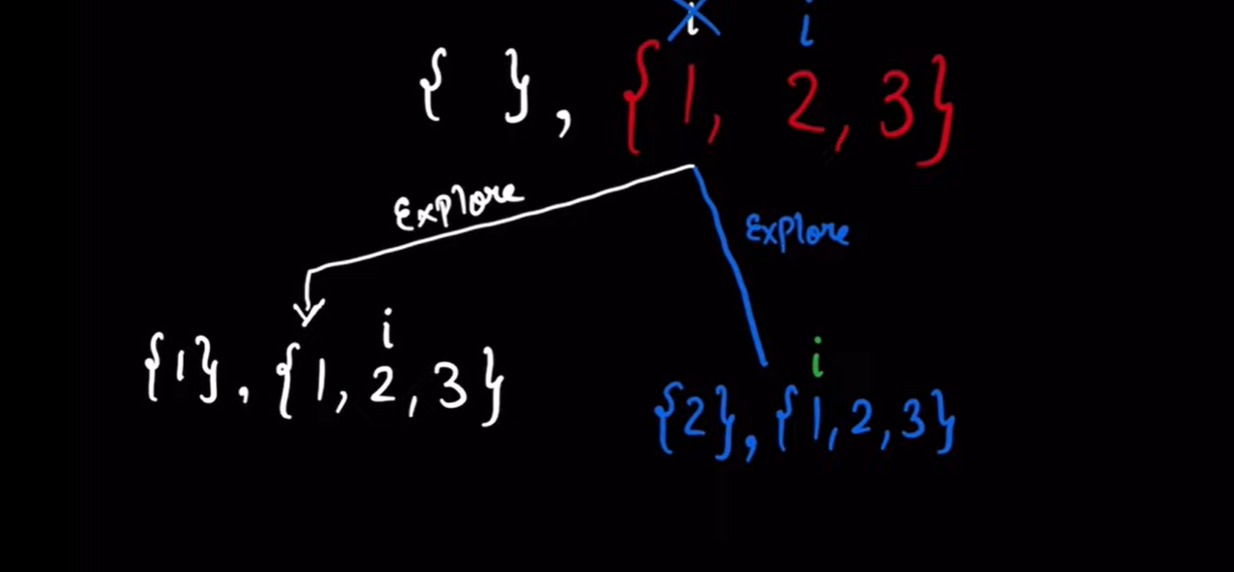
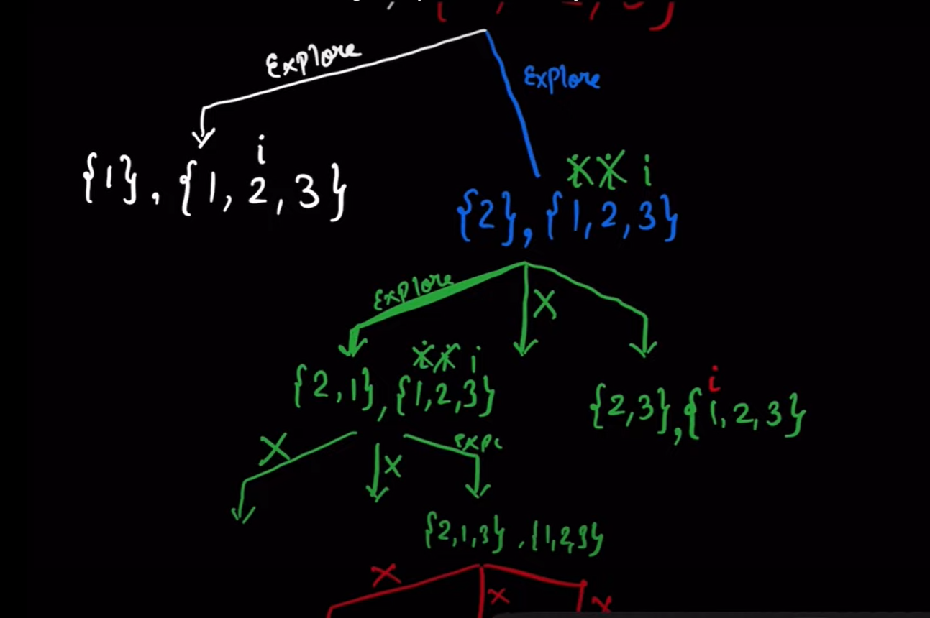

Permutations II:
class Solution {
public List<List<Integer>> permuteUnique(int[] nums) {
List<List<Integer>> data = new ArrayList<>();
Arrays.sort(nums);
backTrack( data, new ArrayList<>() , nums, new boolean[nums.length]);
return data;

}
private void backTrack(List<List<Integer>> data, List<Integer> temp, int[] nums, boolean used[]){

if ( temp.size() == nums.length )
{
data.add(new ArrayList<>(temp));

}
else {
for(int i=0; i<nums.length; i+=1){
if(used[i] || i > 0 && nums[i] == nums[i-1] && !used[i - 1]) continue;
temp.add(nums[i]);
used[i] = true;
backTrack( data, temp, nums, used);
used[i] = false;
temp.remove( temp.size() - 1);

}
}

}
}

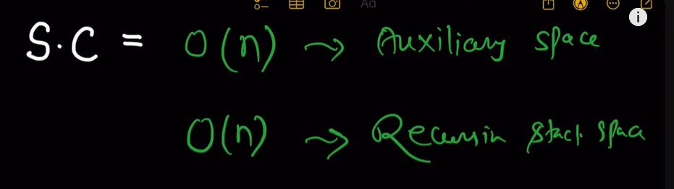
N for copying to 2nd dimension list
